Designing a Smart City Traffic Management Solution: Patterns and Use Case Modelling

An Assignment submitted in partial fulfillment of the requirements for the degree of
Bachelor of Science
in
Computer Science

CS 2401: Software Engineering 1
Term 1 – 2025
University of The People

September 24, 2025

Designing a Smart City Traffic Management Solution: Patterns and Use Case Modelling

Introduction
Effective traffic management is a cornerstone of smart city initiatives, addressing the growing complexity of urban mobility, congestion, and emergency responsiveness. As cities expand and traffic volumes increase, traditional monolithic traffic systems struggle to provide the scalability, flexibility, and real-time data integration required for modern urban environments. Robust software design becomes essential for constructing systems that can adapt to dynamic conditions, integrate diverse data sources, and ensure timely responses to emergencies. This essay explores the application of design patterns, specifically microservices architecture and GRASP (General Responsibility Assignment Software Patterns) principles, in developing a smart city traffic management solution. It also presents a UML use case diagram for an emergency response system, highlighting the roles and interactions of key actors in accessing real-time traffic data during critical events.

Design pattern selection for traffic monitoring
In designing the traffic monitoring module of a smart city traffic management solution, selecting an appropriate architectural pattern is vital. The microservices architecture style, as detailed in the provided references, is particularly suitable for such systems. Microservices break down the overall application into small, autonomous services, each responsible for a specific business capability within a bounded context (RobBagby, 2025). For the traffic monitoring module, this means developing a dedicated service that collects, processes, and distributes real-time traffic data independently from other system components, such as traffic control, analytics, or emergency response subsystems. By leveraging microservices, each module can be developed, deployed, and scaled independently, supporting the agility and resilience demanded by urban traffic management scenarios.

Ensuring cohesion and minimizing coupling
The microservices approach directly addresses the challenges of cohesion and coupling. Cohesion refers to the degree to which the elements within a module belong together, while coupling measures the extent of interdependence between modules. High cohesion and low coupling are desirable for maintainable and scalable software systems (GeeksforGeeks, 2025). In the context of the traffic monitoring module, microservices architecture ensures cohesion by encapsulating all responsibilities related to traffic data collection, processing, and dissemination within a single, well-defined service. This is aligned with the GRASP principle of High Cohesion, which advocates grouping closely related responsibilities to enhance maintainability and clarity.
Similarly, microservices minimize coupling by enforcing well-defined APIs for inter-service communication. The traffic monitoring service exposes endpoints for other modules, such as emergency response or urban analytics, to access real-time traffic data without directly depending on its internal implementation. This aligns with the GRASP principle of Low Coupling, which reduces dependencies between modules and enables independent development and deployment (GeeksforGeeks, 2025). For example, if the data storage technology for the traffic monitoring module is upgraded from SQL to NoSQL, other services remain unaffected as long as the API contract is maintained. This decoupling supports the flexibility and scalability required in dynamic urban environments.
To illustrate, suppose the city introduces a new type of traffic sensor. The traffic monitoring microservice can be updated to support data ingestion from this sensor without impacting the emergency response module, which continues to consume data through the established API. Moreover, the GRASP Information Expert principle suggests assigning responsibilities to the class or service with the required knowledge (GeeksforGeeks, 2025). In this case, the traffic monitoring service, possessing expertise in interpreting sensor data, manages all aspects of traffic data processing, further enhancing cohesion and reducing unnecessary dependencies.

UML use case diagram for the emergency response system
In a smart city, the emergency response system must facilitate rapid access to traffic data for various stakeholders. The UML use case diagram for this system includes four key actors:
- Emergency dispatcher: Initiates and coordinates emergency response efforts, requiring real-time traffic data to determine optimal routes for emergency vehicles.
- First responder: Receives route guidance and traffic updates, relying on the system to avoid congested or blocked areas during incident response.
- Traffic control center operator: Monitors traffic conditions and can adjust signal timings or implement road closures in response to emergencies.
- Public information officer: Communicates with the public and media, providing updates on incidents and traffic disruptions.
The primary use cases involve Access Real-Time Traffic Data, Request Optimal Route, Update Traffic Signals, and Disseminate Traffic Alerts. The Emergency Dispatcher interacts with the system to access real-time data and request optimal routes, while the First Responder receives this information. The Traffic Control Center Operator updates traffic signals based on current conditions and emergency needs. The Public Information Officer accesses the latest incident data to inform the public. All actors depend on the traffic monitoring module, which supplies accurate, up-to-date information via standardized APIs. This modular interaction exemplifies low coupling, as each actor’s interface with the system is abstracted from the internal workings of the traffic monitoring service.
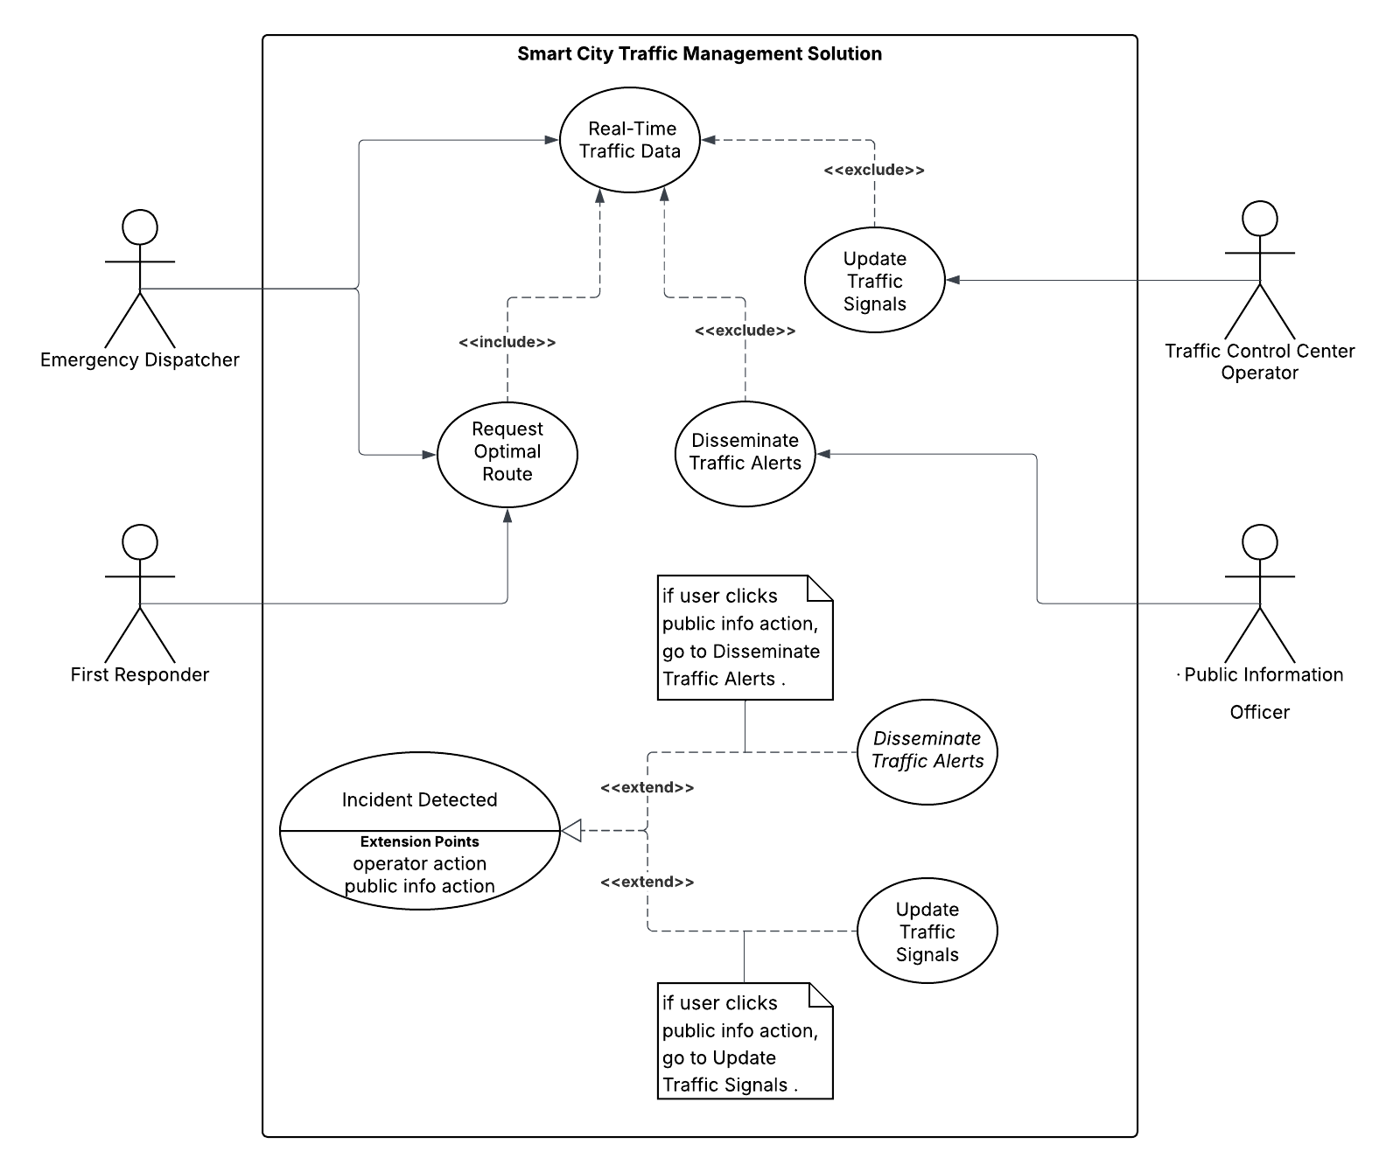
This use case structure demonstrates how clear system boundaries, defined by microservices and GRASP principles, enable efficient, real-time collaboration during emergencies.

Conclusion
Designing a smart city traffic management solution requires architectural patterns that ensure maintainability, scalability, and resilience. The microservices architecture, supported by GRASP design principles, provides a robust framework for structuring the traffic monitoring module, achieving high cohesion and low coupling. Through well-defined APIs and responsibility assignment based on domain expertise, the system remains flexible and adaptable to changing urban needs. The UML use case diagram for the emergency response system underscores the importance of clear actor roles and interactions, facilitating rapid, coordinated responses during critical events. Ultimately, the thoughtful application of design patterns and systematic modelling enables smart city systems to evolve efficiently, supporting safer and more responsive urban environments.

References
GeeksforGeeks. (2025, August 28). GRASP design principles in OOAD. https://www.geeksforgeeks.org/system-design/grasp-design-principles-in-ooad/
RobBagby. (2025, November 7). Microservices architecture style. Microsoft Ignite. https://learn.microsoft.com/en-us/azure/architecture/guide/architecture-styles/microservices

